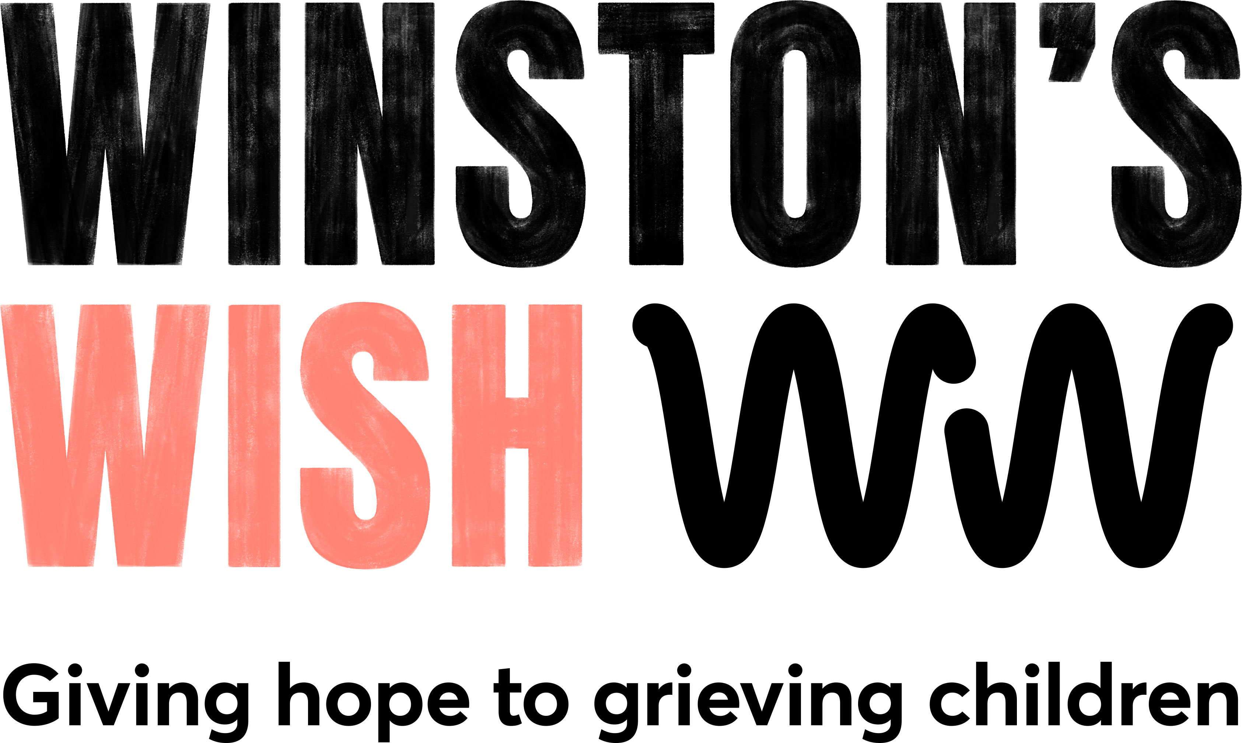

VOLUNTEER APPLICATION FORM

Volunteer role applied for:
Where did you see this role advertised?

PERSONAL INFORMATION
Please see our Privacy Policy, which explains how we collect, manage, use and protect your personal data, at www.winstonswish.org/privacy-statement.
First name(s): |  |  | Surname:
Home address:
Email address:
Telephone number (s) and/or mobile no.
Date of birth:

PROFESSIONAL QUALIFICATIONS (OBTAINED OR WORKING TOWARDS) AND MEMBERSHIP OF PROFESSIONAL BODIES

Dates (from/to) | Professional qualification or membership body (including membership number)

WORK HISTORY AND RECORD

Starting with the most recent, please give details of any present and previous experience. You should include all types of employment, be that full or part time, permanent or temporary. You may also detail below voluntary work that you have undertaken. Please explain any gaps in your work history of more than 12 weeks.

Dates  (from/to, including month and year) | Name and address of employer and sector/nature of business | Post title(s)/brief outline of duties/job grade | Reason for leaving (or intending to leave) post

What is your experience of working in a counselling role?

What do you think are the most important skills to possess when working with bereaved children and young people?

What has motivated you to apply to become a Winston’s Wish volunteer counsellor?

Tell us a bit about yourself including your skills, interests and hobbies
Can you commit to 3 – 4 hours a week, Monday to Friday and monthly supervision? | YES / NO
When are you available to volunteer? E.g. certain days of the week, flexible

SUPPORTING STATEMENT

Please set out below any further information which you feel supports your application.

REFERENCES

As an organisation working with children and young people, we require references. Please provide details of two people who would be prepared to provide a reference.

We reserve the right to approach any of your referees, or organisation where you have worked in an unpaid capacity, without further notification to you.

Referee 1 |  | Referee 2
Name: |  | Name:
Job title: |  | Job title:
Address: |  | Address:
Phone: |  | Phone:
Email: |  | Email:
How long have you know this person? |  | How long have you known this person?
In what capacity do you know them? |  | In what capacity do you know them?

STRICTLY CONFIDENTIAL
SELF-DISCLOSURE FORM FOR ROLES INVOLVING
‘NON-REGULATED ACTIVITY’

As part of the volunteer application process, please also complete this form.

As Winston’s Wish is an organisation working with children and young people, you will also be required to provide a valid Disclosure and Barring Service (DBS) certificate, which will provide details of criminal convictions. You will be sent a link via email to enable you to apply for a DBS check online.

All information you provide will be treated as confidential and managed in accordance with relevant data protection legislation and guidance. You have a right of access to information held on you under the Data Protection Act 1998.

ROLE
NAME OF INDIVIDUAL
PREVIOUS NAME(S)
ADDRESS AND POSTCODE
TELEPHONE NO.
DATE OF BIRTH
GENDER

Please indicate YES or NO to each question:
Have you ever been known to any children’s services department or to the police as being a risk or potential risk to children? | YES / NO
If yes, please provide further information:
Have you been the subject of any disciplinary investigation and/or sanction by any organisation due to concerns about your behaviour towards children? | YES / NO
If yes, please provide further information and include details of the outcome:
Do you have any unspent convictions? | YES / NO
If yes, please provide further information:

Confirmation of Declaration (please tick boxes below)
I agree that the information provided here may be processed in connection with recruitment purposes and I understand that an offer of a voluntary role may be withdrawn if information is not disclosed by me and subsequently comes to the organisation’s attention.
In accordance with the organisation’s procedures, if required I agree to provide / apply for a valid DBS certificate and consent to the organisation clarifying any information provided on the disclosure with the agencies providing it.
I agree to inform the organisation within 24 hours if I am subsequently investigated by any agency or organisation in relation to concerns about my behaviour towards children or young people.
I understand that the information contained on this form, the results of the DBS check and information supplied by third parties may be supplied by the organisation to other persons or organisations in circumstances where this is considered necessary to safeguard children.

Please note that all successful qualified volunteer counsellors will be required to undergo an enhanced Disclosure and Barring Service check.

OTHER DECLARATIONS

Data Protection
“I give permission for Winston's Wish to process and hold on computer the information or data I have supplied or referred to on this application, including any information that I consider to be sensitive and personal. I understand and agree that this information will also be held on my personal file, if I am successful in becoming a volunteer.”

“I agree that Winston's Wish may use the information provided in this application form for equality monitoring purposes, compiling statistics and maintaining other volunteer records.”

Application Submission
“In submitting this application form, I confirm that the information I have given is correct and complete and I understand that giving misleading or untruthful statements may result in the withdrawal of the offer of being a Winston’s Wish volunteer.”

SIGNATURE
PRINT NAME
DATE

Winston’s Wish is a Registered Charity number (England & Wales) 1061359 & (Scotland) SC041140

Please send the completed application form to volunteer@winstonswish.org

